Hyperparameter Tuning With Ray
Steven Bontius | HAN Applied University | March 15th 2026

Introduction
This report documents a systematic hyperparameter tuning study of a configurable Convolutional Neural Network (CNN) on the Street View House Numbers (SVHN) dataset. SVHN consists of 73,257 training and 26,032 test images of real-world house numbers (32x32 RGB), containing challenges including background clutter, multi-digit context, and class imbalance (digit 1 accounts for ~19% of samples).

Three experiments are conducted: baseline, architecture search, and regularization tuning. All experiments use early stopping with patience=5 to prevent overfitting and ensure fair comparison across trials.
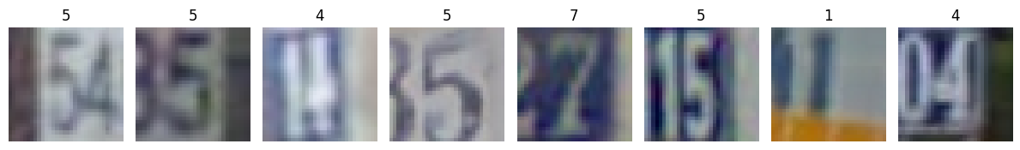
Figure 1. Examples from the image set

Model Architecture
The model is a configurable CNN consisting of num_layers convolutional blocks. Each block contains:

- Conv2d (3x3 kernel, padding=1)
- Optional BatchNorm2d
- ReLU activation
- MaxPool2d (2x2)

Filters double each layer starting from num_filters. The classifier layer flattens the output and passes it through a linear layer with num_hidden_units neurons, ReLU, optional Dropout, and a final 10-class output layer. CrossEntropyLoss is used as the loss function and Adam as the optimizer with learning rate 0.001. The batch size is 32.

Baseline
Based on the limited dimensions of the images a rather small model is created as a baseline. The baseline will act as the starting point for further tuning.

Parameter | Value
num_layers | 3
num_filters | 32
num_hidden_units | 128
Table 1. Baseline model parameters
The model exhibited clear overfitting, evidenced by a significant loss gap of 0.180 (Train: 0.175, Test: 0.356). Peak performance occurred at epoch 6 with a test accuracy of 90.6%

Experiment 1: Architecture Search
Hypothesis: The model is currently overfitting because it has more capacity than it needs for this data. Adding more layers or filters will likely just make the overfitting worse. I expect that by experimenting with the architecture, I'll find a simpler setup that stops memorizing the training noise and actually starts learning the patterns.
Search space (20 random trials, 42% of 48 combinations)
Parameter | Values
num_layers | 2, 3, 4
num_filters | 16, 32, 64 ,128
num_hidden_units | 64, 128, 256, 512
Table 2. Search space experiment 1
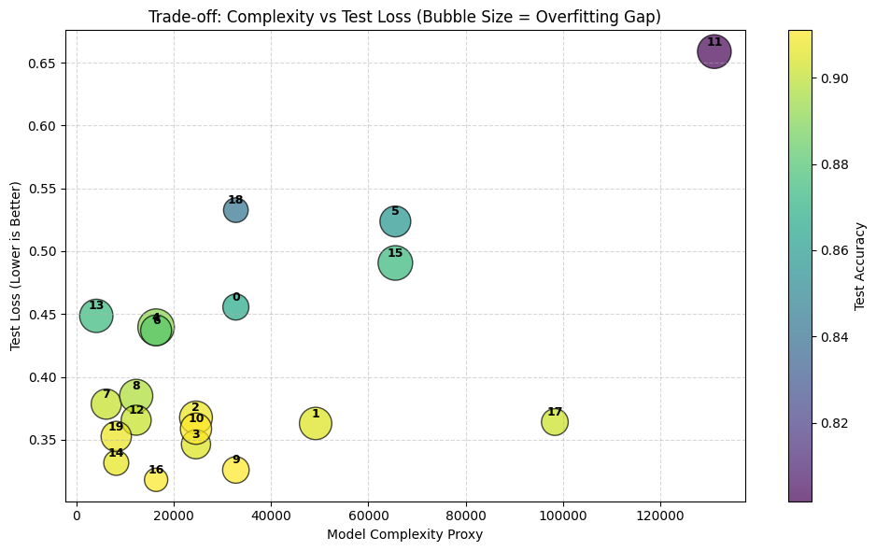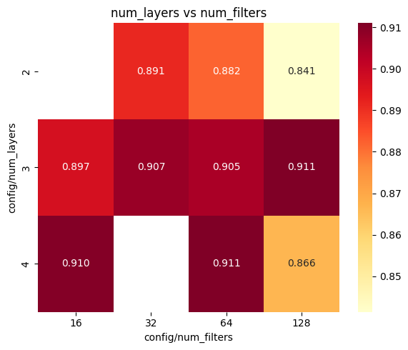
Figure 2. Model complexity vs performance Figure 3. Heatmap filters vs layers
Results: Accuracy ranged from 0.84 to 0.91 across all trials. 2 layers performed consistently worse, while 3 and 4 layers showed similar results. No clear winner emerged for num_filters or num_hidden_units.
The bubble chart reveals that higher model complexity consistently leads to larger overfitting gaps and worse test loss. The sweet spot lies at low to medium complexity.
Conclusion: The hypothesis was partially confirmed. Lower complexity models showed smaller overfitting gaps and lower test loss, consistent with the expectation that excess capacity leads to memorization. However, the best performing trial (Trial 16: 4 layers, 16 filters, 256 hidden units) was not the simplest model overall, suggesting that some complexity enhances performance. The persistent overfitting motivates investigation of regularization in Experiment 2.

Experiment 2: Regularization
Hypothesis: Adding BatchNorm and dropout to the best architecture (4 layers, 16 filters, 256 hidden units) will reduce the overfitting gap while maintaining or improving accuracy. BatchNorm stabilizes training by normalizing layer inputs, while dropout prevents co-adaptation of neurons.
Search space (25 random trials)
Parameter | Values
batch_norm | True, False
drop_out | uniform (0.0, 0.5)
Table 3. Search space experiment 2
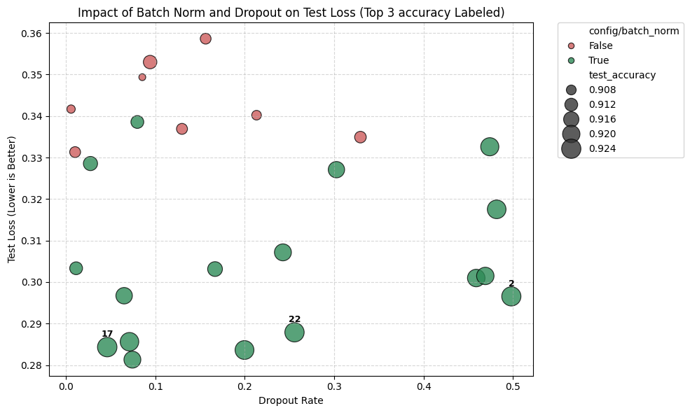
Figure 4. Drop out rate vs test loss
BatchNorm consistently improved accuracy by ~1% and reduced test loss across all dropout values. Dropout showed no clear trend in either direction, suggesting its effect is small relative to initialization variance for this model size.
Best trial [17]: BatchNorm=True, dropout=0.046, test accuracy 92.44%, loss gap 0.14.
Conclusion: BatchNorm is the primary driver of improvement. The hypothesis was partially confirmed: BatchNorm reduces overfitting and improves accuracy. Dropout's effect could not be isolated reliably.
Note: To investigate whether Bayesian optimization could find better configurations more efficiently, Experiment 2 was rerun using Optuna as the search algorithm. Results were marginal: best accuracy improved slightly from 92.44% to 92.74% while mean accuracy was lower (91.43% vs 91.60%). Optuna sampled more heavily in the higher dropout range, likely misled by high initialization variance in early low-dropout trials. See figure 5. For small noisy search spaces, random search proved equally effective.
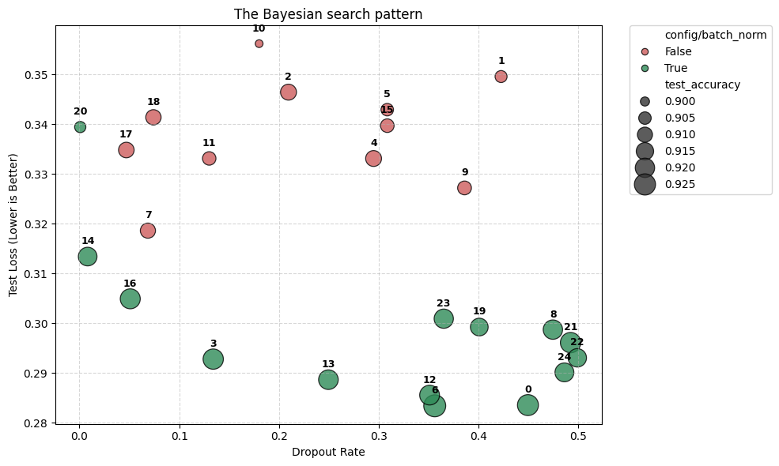
Figure 5. Bayesian search pattern

Conclusion and limitations
This study systematically investigated hyperparameter tuning of a configurable CNN on the SVHN dataset through two experiments. The iterative approach of first searching the architecture space before tuning regularization proved computationally efficient. Experiment 1 identified that high complexity models (large number of filters and parameters) both performed worse and took significantly longer to train. Eliminating these from the search space in Experiment 2 reduced compute time considerably while focusing the search on more promising configurations.
Key findings are:
- Architecture alone does not resolve overfitting. All 20 trials in Experiment 1 showed a positive loss gap regardless of complexity, with accuracy ranging narrowly from 0.84 to 0.91.
- Batchnorm is a useful tool. Adding Batchnorm improved test accuracy while at the same time reduce the overfitting gap.
- Drop out had no measurable effect for this model. High initialization variance made it impossible to isolate the effect.
- Bayesian optimization provided no benefit over random search for this small search space, and appeared to be misled by unlucky trials.
The overall accuracy gain from 90.6% to 92.4% across all experiments is modest. This is not surprising given the nature of the dataset: SVHN images are low resolution (32x32), contain background clutter, and often show multiple digits where only the center digit is labeled. These are genuinely difficult conditions even for a human observer, and a simple CNN without data augmentation or pretraining has inherent limits on how well it can generalize under these conditions.
Experiment | Accuracy | Test loss | Loss Gap
Baseline | 0.906 | 0.356 | 0.180
Exp 1: Architecture | 0.911 | 0.318 | 0.107
Exp 2: Regularization (random) | 0.924 | 0.284 | 0.144
Table 4. Overall results
Limitations: Results are based on single trials per configuration, meaning initialization variance may explain differences as much as the hyperparameters themselves. No learning rate scheduler or data augmentation was used, both of which could further reduce the overfitting gap.

